NSAA WRESTLING NEWSLETTER 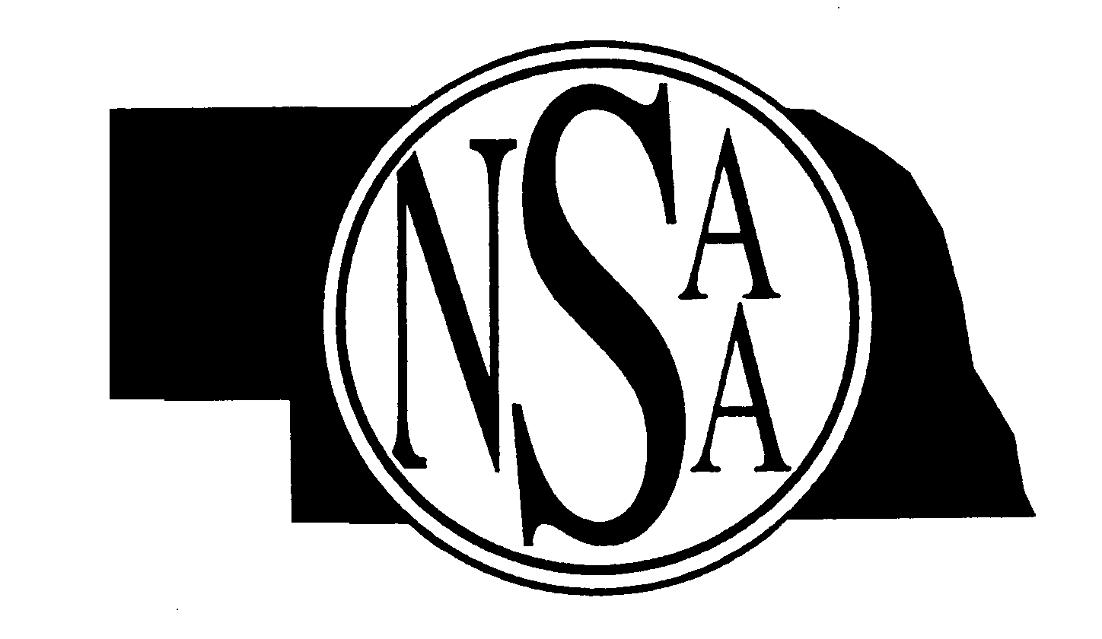


Volume #1 December 2005
A Publication by the Nebraska School Activities Association
for Wrestling Coaches and Officials registered with the NSAA
Edited by Bob Colgate, Assistant Director

Mailing Address: PO Box 5447, Lincoln, NE 68505-0447 Phone: 402-489-0386

Comments
The 2005-06 wrestling season is off to a great start. Early reports are that most teams are staying pretty healthy. We have had some reports of teams starting to battle the yearly flu bug already. I would like to commend ALL wrestlers, coaches and wrestling officials on their job in emphasizing sportsmanship both on and off of the mat in all meets so far this December. Coaches, please visit with your parents about sportsmanship, as we have had reports of some problems with them at some December meets already. Good luck the rest of the season!

NSAA Wrestling Official Observers: Rex Jones, Duane Choutka, Bill Tuma and Jim Ayres, NSAA Official Observers, are assisting Bob Colgate, NSAA in observing and evaluating wrestling officials for the 2005-06 season.

NSAA Weight Certification: The NSAA is reminding all Head Wrestling Coaches to make sure that they get ALL of their wrestler’s weight certified by December 25, 2005. A wrestler who has not been certified by December 25, 2005 due to ILLNESS, INJURY, or NON-PARTICIPATION must certify thereafter the first time he/she wrestles interscholastically or is awarded a point(s) for a forfeit. Also coaches, be sure to mail the NSAA office the white copy of ALL of your NSAA Weight Certification forms by January 2, 2006. Submit the Late Certification forms as soon as you get those wrestlers certified. Coaches and officials please make sure ALL of the Weight Certification forms are completed correctly before submitting to the NSAA.

State Wrestling Tickets: The remaining NSAA State Wrestling Tickets will go on sale on Monday, January 2, 2006 at 10:00 AM. Tickets available at all Ticketmaster retail ticket center locations, Ticketmaster charge-by-phone in Omaha at (402)-422-1212 and Lincoln (402)-475-1212, online at Ticketmaster.com or at Qwest Center Omaha Box Office.

Registered NSAA Wrestling Officials: The total number of Nebraska wrestling officials registered was 180. The breakdown by Classification is as follows: Registered – 99; Approved – 18; Certified – 63. The total number of Affiliated officials who registered from out of state was eight. The NSAA thanks all coaches and officials in their efforts to recruit new wrestling officials.

Wrestling Ejections Update: The following numbers represent the total number of ejections for wrestling as reported to the NSAA office as of December 15, 2005: Wrestlers = 5 (3-Varsity, 2-JV) and Coaches = 0. If you have an ejection, officials are reminded to make sure that they file the ejection report with the NSAA office right after the meet. The NSAA Ejection Report form is located on the NSAA web site under the “Officials Login Page”.

Weight Allowance: I have had a lot of questions recently about weight allowance. All wrestlers who have their weight certified get a two-pound growth allowance—after December 25th. Also, there has been some confusion to NFHS Rules 4-4-2 and 1-3-2a. NFHS Rule 4-4-2 allows a contestant to wrestle at no more than one weight class above that class for which his/her actual stripped weight, at time of weigh-in, qualifies him/her. NFHS Rule 1-3-2a allows a contestant to weigh-in at one weight class above the weight certification without recertifying at a higher weight. The following is an example of how these two rules would apply: A wrestler who certified at 130 lbs. weight class, may weigh-in at 135 lbs. and wrestle at 140 lbs. and still be certified at 130 lbs.

OFFICIALS
The NSAA will assign officials to Districts in early January 2006. Contracts that are issued to assigned oficials will be posted on the NSAA website on the Officials Login page. The State Wrestling contracts will be handled the same way and will be posted at the end of January.

Reminders for Athletic Directors – Wrestling Coaches – Wrestling Officials
- ALL varsity and non-varsity meets need to follow all of the 2005-06 NFHS Wrestling Rules and the NSAA rules for wrestling.
- NSAA Approved Ruling 3.11.1: During a sport’s season, a school shall not permit a student who is not a member of the high school’s team, an adult, a college student, or alumni to participate in any practice session, drill, scrimmage, or game in which the school team is involved. This does not prevent the coach from being involved for the primary purpose of coaching, or demonstrating a skill, method, or techniques. Junior High wrestlers cannot workout with the high school wrestling team.
- ALL wrestlers must keep their uniforms on while in the competition area. The competition area is defined as the gym. Coaches are to make sure that ALL of their wrestlers comply with this NSAA Approved Ruling in all meets. Wrestling Officials are only to enforce NFHS Rule 7-4-2 – (Shoulder Straps – Unsportsmanlike Conduct): Failure to keep shoulder straps up while on the mat will result in a match point or team point deduction. Once the wrestlers are off of the mat, Wrestling Officials no longer need to enforce NFHS Rule 7-4-2.
- Please make sure all individuals are following the NFHS Communicable Disease Procedures are stated in the front of the 2005-06 NFHS Wrestling Rules Book. Wrestling Officials are not to clean up blood or body fluid on the mats or on wrestlers. The host school is responsible for providing an individual to do this task.
- The rubber wristband is popular among wrestlers. The NFHS Rules Review Committee has agreed that this wristband, like any adornment, shall be treated as jewelry and be removed during participation.
- Wrestling Officials—Do NOT cut the hair of a wrestler or trim their fingernails.
SITUATION 1: When the growth allowance is used, how does if affect weight classes? RULING: When the growth allowance is used, each weight class is, in essence, increased by 2 pounds. All reference to weight classes will remain the same, but, in reality, the 103-pound class becomes 105 pounds, the 125-pound class becomes 127 pounds, etc. COMMENT: An individual can only be qualified to wrestle in two weight classes, the one in which the actual stripped weight qualifies the competitor for and one weight class up. Therefore, after the growth allowance is in effect, in order to be considered as a 125-pound contestant, an individual must weigh in excess of 121 pounds and no more than 127 pounds. The wrestler could then wrestle in either the 125-pound class or the 130-pound class. (4-4-2; 4-4-4)
SITUATION 2: Wrestler A is certified at 130 pounds and, after the two-pound growth allowance is in effect, weighs in for a dual meet at 133 pounds and wrestles at 140 pounds. Would it be permissible for this wrestler to maintain certification at 130 pounds? RULING: Yes, it would be permissible for the wrestler to maintain the 130-pound certification. In order to remain certified at 130 pounds, a wrestler must have at least one half of his weigh-ins during the season at the minimum weight to be wrestled at the state tournament series. A wrestler is allowed to weigh-in one weight class up on no more than one-half of all matches. By weighing in one weight class up, the wrestler can either wrestle at that weight class or one weight class up. This individual, when weighing in at 133 pounds, would be a 135-pound contestant and could wrestle at either 135 or 140. Should the wrestler weigh in at 138 pounds, either 140-pound class or the 145-pound class may be competed in, but unable to maintain certification at 130 pounds. (1-3-2)
SITUATION 3: During a tournament, Wrestler A, out of frustration, (a) intentionally hits Wrestler B following an illegal hold by B, (b) following a fall over B, intentionally kicks B in the side; or (c) A intentionally bites B because B repeatedly placed hands in A’s face during a pinning situation. RULING: In (a), it is flagrant misconduct, which results in A’s disqualification in the match, removal from the tournament and three team points deducted. B would be declared the winner of the contest. In (b), A will be disqualified for flagrant misconduct, have three team points deducted and shall be removed from the tournament. There would be no winner of this contest. In (c), it is flagrant misconduct by A which results in the disqualification of A from the tournament plus a three team point deduction. B would be declared the winner. Any contestant so disqualified is not entitled to any points he has earned previously in the tournament. All advancement points, fall points, placement points, etc. are negated. (8-1-6; 7-4-3)
SITUATION 4: Wrestler A has the choice at the beginning of the second period. The referee inadvertently gives the choice to Wrestler B. B selects the top position and during the course of action pins A. After the end-of-match procedure, the coach of A indicates his wrestler had the choice at the beginning of the period. After reviewing with the scorekeeper and checking the choice selected at the captains meeting, the referee agrees with the coach. The referee re-starts the second period by giving A the choice. RULING: This is a correctable
error because there is not an opportunity for A to have a choice of position in the subsequent period. (5-1-1; 6-6-2b)
SITUATION 5: Wrestler A is leading by a score of 11-0 in the second period. The wrestlers are in the neutral position when A takes B directly to the mat and holds B there long enough to earn a three-point near-fall. B then indicates an injury. The referee stops the match due to the injury. The referee begins injury time for B and awards A two points for the takedown and four points for the near fall, making the score 17-0. Is the match concluded? RULING: Yes. There are two scenarios. First, the match was stopped due to the injury, not the technical fall. If there had been no injury, the referee would have let the match continue until a fall was secured, the pinning situation ended, the wrestlers went out of bounds, or time expired. At that point, A would have been declared the winner by a technical fall or by a fall if criteria had been met. In this situation, the injury caused the stoppage. An injury time-out must be called and injury time used. If B can continue, then A wins by a technical fall; if B cannot continue, A wins by default. (5-11-2h; 5-11-4a; 5-29-1, 2)
SITUATION 6: Wrestler A comes to weigh-ins with a current form from a physician stating that the wrestler’s skin condition is not communicable. The official conducting weigh-ins asks the on-site physician to look at the wrestler’s skin condition. The physician determines the skin condition is communicable. RULING: An on-site physician may overrule the diagnosis of the physician who has indicated, in writing, that the apparent skin condition is not communicable. (4-2-4)
SITUATION 7: Wrestler A is apparently unconscious. May the wrestler compete if the wrestler’s parents sign a waiver to permit continued competition? RULING: No. A physician (M.D./D.O.) is the only one who can allow a wrestler to continue, and this release must be in writing. (8-2-4)
SITUATION 8: The second day of a tournament falls on a national educational testing date (SAT, ACT, etc.). Weigh-ins are scheduled for 8 a.m. May the host school principal grant special permission for a wrestler to weigh in at the conclusion of wrestling on the previous day? RULING: No. (4-5-1)
SITUATION 9: In a multiple school event, the random draw indicates the 125-pound weight class will be competed first. At the conclusion of the first dual meet, the coaches agree that there has been sufficient time to allow the second match to start with the 125-pound weight class. The official allows the second dual meet to start at the 125-pound weight class. RULING: Incorrect. The 130-pound weight class should have been the first match for the second dual meet. (1-1-2)

Nebraska School Activities Association
NON-PROFIT ORG.

U.S. POSTAGE
PAID

Lincoln, NE
Permit No. 269
8230 Beechwood Dr.
PO Box 5447

Lincoln, NE 68505-0447

RETURN SERVICE REQUESTED

